Fit for Life
Proudly Sponsored By:

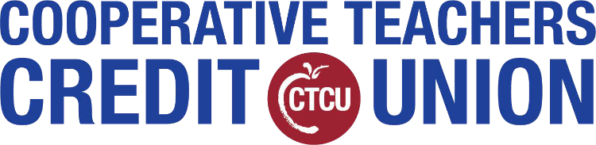
Youth Art Contest

2021 Artist Entry Form

Art Project Title: Describe the meaning of your artwork
(if more space is needed, then please use the back side of this entry form)

Student's Name: School: Grade: Name of Art Teacher: Art Teacher's E-mail:

Name(s) of Parent/Guardian:
E-mail of Parent/Guardian:

Entry Requirements: Only original works of art inspired by the theme “Fit for Life” may be submitted. Each entry must be the original work of one student only. An adult may not alter the creative integrity of a student’s work. Because the program is designed to encourage and recognize each student’s individual creativity, help from an adult or collaboration with other students is not allowed. Only one student may be recognized as the award recipient for each entry. Each entry must contain a title and all entries must include an artist statement.

The artist statement communicates what inspired the work, how it relates to the theme, and the content of the work. The statement must include at least one sentence but may not exceed 100 words. Ownership in any submission shall remain the property of the entrant, but entry into this program constitutes entrant’s irrevocable permission and consent that Fit City Tyler may display, copy, reproduce, enhance, print, sub-license, publish, distribute and create derivative works for Fit City Tyler purposes. Fit City Tyler or its affiliates are not responsible for lost or damaged entries. Submission of entry into the Fit City Tyler Youth Art contest constitutes acceptance of all rules and conditions.

Your entry must be postmarked no later than Thursday, April 15, 2021.

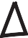
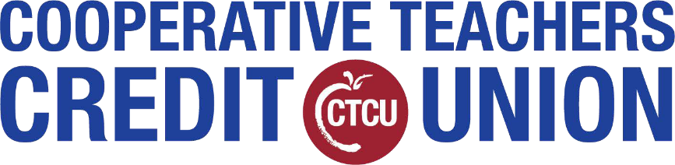
youth contest
proudly sponsored by:
Fit for Life
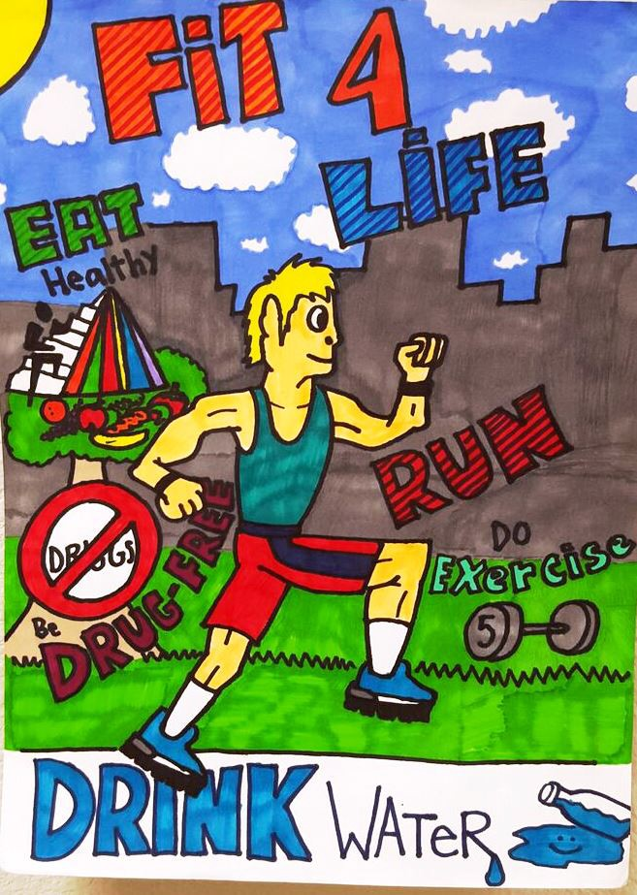
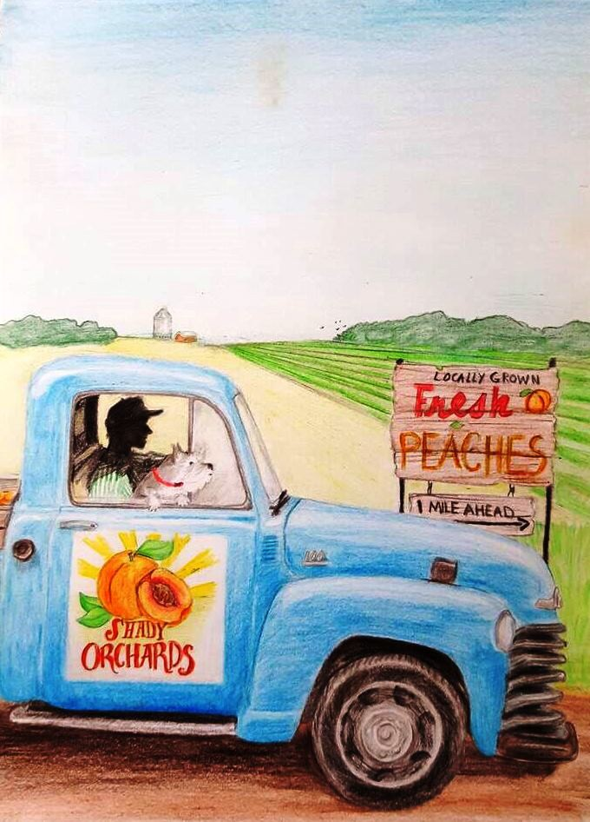
We invite all aspiring artists to submit their original artwork into the 6th annual "Fit For Life" Youth Art Contest!
1st place = $100 2nd place = $75 3rd place = $50

The contest is open to any public, private, charter, or home-schooled student currently enrolled within the following grades:
- Kindergarten through second grade
- Third through fifth grade
- Sixth through eighth grade
- Ninth through 12th grade
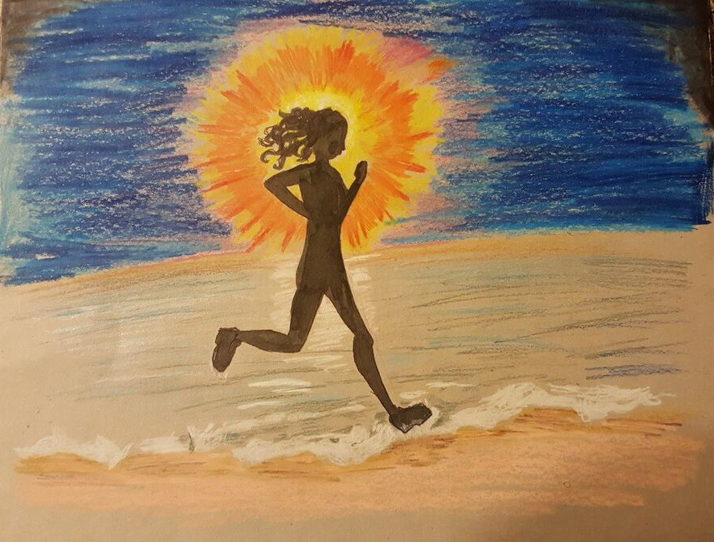
Entry forms must accompany each submission. Entries must be postmarked by April 15, 2021. Finalists will be notified in late June, and winners will be announced at the Fit City Tyler Celebration Event that will be held later in 2021.
Winners will be selected based on creativity, artist statement, and diversity.
To enter the 2021 Fit for Life Youth Art Contest, children should mail their original artwork to the mailing address below:

Fit City Tyler
ATTN: Terrence Ates
315 North Broadway, Suite 404
Tyler, Texas 75701
For more information, please visit FitCityTyler.com.

